Installation:
Mechanical aptitude is essential for successful installation.
Most 24" or 26" bicycle with diamond frame and a horizontal top tube should have sufficient space to mount the engine
--------------------------------------------------------------------------------
Step 1: The rear wheel sprocket shall be mounted first!
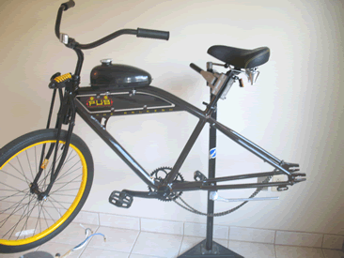
Remove the rear wheel from the bicycle.
Sprocket:
Remove the rear wheel sprocket and associated mounting accessories from the bag
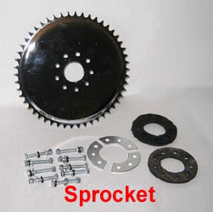
Slit one of the rubber washer as shown. This is to allow the rubber washer to go around the rear wheel shaft.
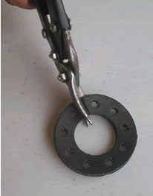
Insert the rubber washers as shown
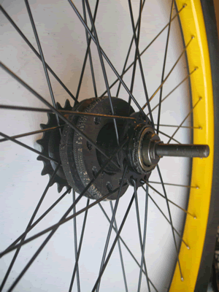
- Mount the sprocket to the rear wheel as shown.
- Do not over-tighten and make sure that the sprocket is exactly perpendicular to the axis of the wheel.
- Reinstall the rear wheel to bicycle.
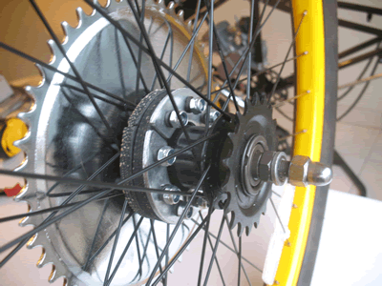
Next: The engine
- The engine is designed to fit between the down tube and the seat tube of a standard diamond frame bicycle. Other types of bicycle may require slight modifications.

- Position the engine so that when the exhaust silencer is installed, it points towards the ground nearly parallel to the down tube.

- The exhaust silencer needs to be removed to tighten the mounting nuts.
So when positioning the engine, there is no need to tighten the exhaust silencer to the engine.
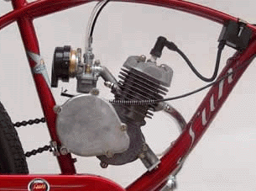
NOTE: If the bicycle frame tubing is too large then you will have to use the bicycle frame adapter. (metal plate with 3 holes in the same plastic bag there are 3 bolts; 2 that go into the
motor and one longer one that goes through the bike frame then through the motor mount)
As shown on photos below:
Bicycle frame adapter Insert the 2 shortst bolts in to the motor
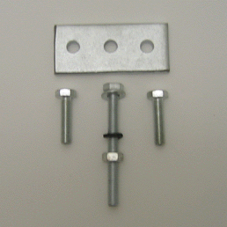 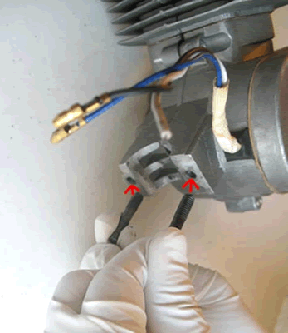
Place the engine on the bicycle frame as shown on photo.
Mark the area of the center hole of the bicycle frame adapter, you will need to drill a hole through the bike
Bicycle frame adapter installed to the engine frame on that area.
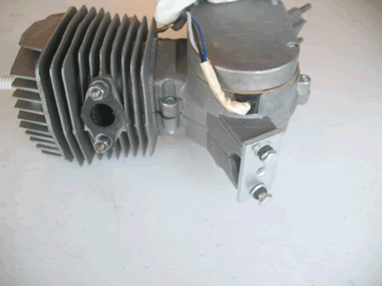 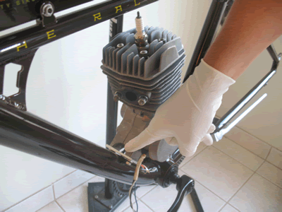
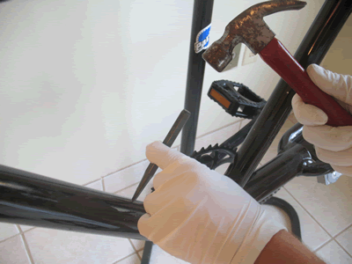 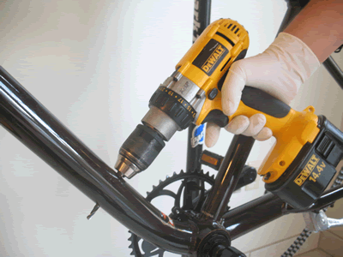
The longer bolt goes through the bike frame then through the motor mount)
As shown on photos below:
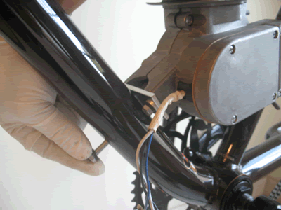
NEXT: Chain drive:
- Remove chain cover and spark plug.
- Break chain and feed into drive sprocket on engine. Use box spanner provided to crank chain around drive sprocket.
- Remove excess chain and reconnect.
- Install chain guide pulley.
- Do not over-tension the chain.
- Install chain guard and replace spark plug.
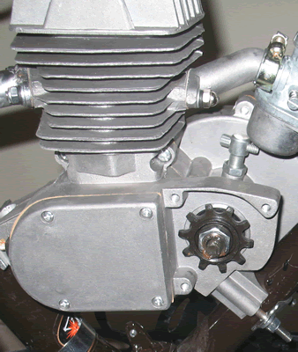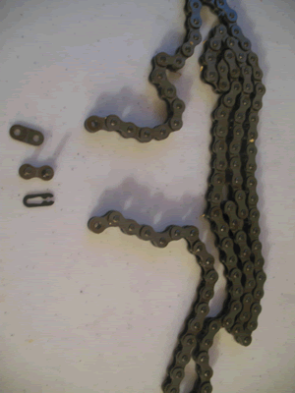
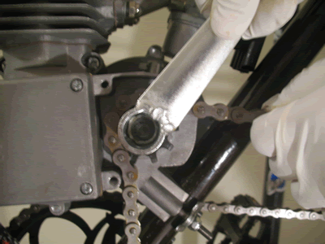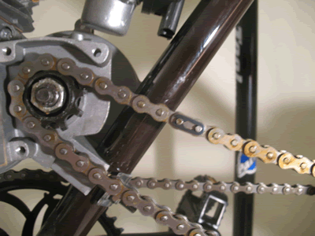
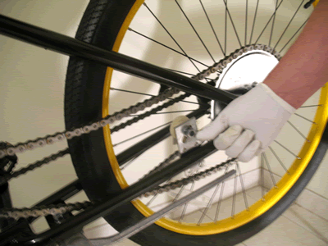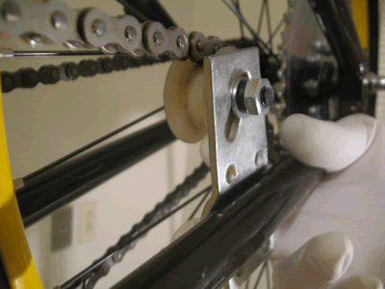
Next: CDI
The CDI is part of the electronic ignition system for the engine.
Secure the CDI to the down tube as shown.
Connect the cable to the spark plug and the 2 wires to the magneto coil wires from the engine.
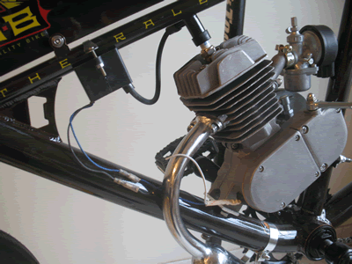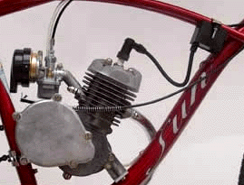

Next: Clutch
Install clutch lever under left handle brake lever.
Run cable down to engine.
Insert heat protective spring (bigger spring wire) over cable.
Insert cable through anchor pivot.
Insert spring return over clutch cable. Tighten cable to clutch lever on engine, ensuring that slack just taken out.
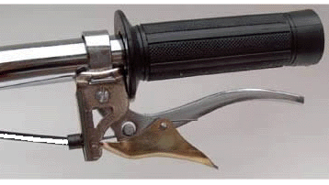
The carburetor in the picture bellow was taken out for clarity. The completed installation should look like this.
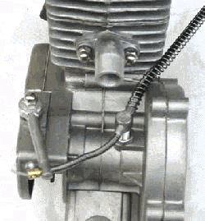 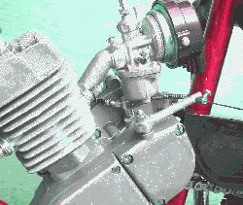
Next: Throttle
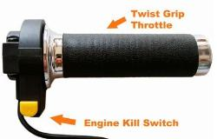
Remove existing right handle grip and replace with twist throttle.
Existing brake lever loosen and shifted to facilitate installation of twist throttle.
Replace brake lever in its original position after installation of the twist throttle.
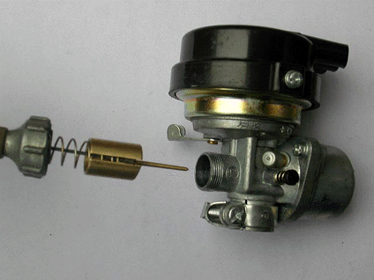
Remove valve mechanism from the carburetor.
Insert throttle cable through screw cap. Insert spring return and attached end of cable to valve plunger.
Line up the cable and spring.
Run cable down to engine; Replace above mechanism into the carburetor.
Next: Fuel tank
Finally, mount the fuel tank over the top tube.
Tighten the fuel valve to the tank.
Cut supply fuel line to length and connect fuel valve to carburetor.
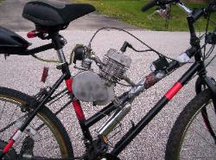
Ready to go
Secure loose cables to frame of bicycle with cable tie (not done in pictures).
Fill fuel and lubricant mixture in accordance with recommendation on the manual.
Compress the clutch and start cycling bike as normal. When sufficient speed is reached, release the clutch. This will start the engine.
To stop, compress and engage the clutch lever. Brake as normal.
To stop the engine, choke the carburetor completely with the lever on the carburetor. Alternatively, press the kill switch which is provided. When engine is not running shut of fuel valve
completely.
--------------------------------------------------------------------------------
1.IMPORTANT: PLEASE READ THIS: Gas and Oil Mixture for Fuel ratio
The engine is a 2 cycle design, therefore, a gasoline/oil mixture is necessary. During the break-in period (1st gallon of fuel), the ratio for 49cc is 25 parts gasoline to 1 part oil. Break in
ratio for 80cc is 20 to 1. After the break-in period, the ratio is increased to 30 to 35 parts gasoline to 1 part oil.
*NOTE: Use only Synthetic 2 Stroke Oil to insure proper engine lubrication.
!WARNING! Remember safety first: Wipe up any spilled fuel. NEVER fuel a hot engine or smoke while fueling. This could result in sudden fire, personal injury. Always move your motorized
bike at least 10 feet from any fueling area before attempting to start it. Never leave the tank fuel cap off after fueling as rain water will contaminate the fuel and cause engine failure.
2. Open the fuel valve. Small lever pointed down with fuel line is in the open position.
3 Depress the small round cap plunger, ( Tickle button ), to prime carburetor. Located on
left side of the carburetor next to the idle adjust screw. One or two times is enough.
4. Lift choke lever to the upward position. This is the small lever on the right side of the
carburetor. All the way Up the choke is on. All the way Down the choke is off. Move
progressively downward to off position during engine warm up period.
5. Pull the handlebar clutch lever inward, to disengage the engine from the rear wheel.
6. Pedal; (down hill if possible for first start)
7. Let out the clutch lever all the way out and continuing to pedal. The result is a direct engine hook up with the rear wheel via chain and sprocket and the engine will now start spinning,
Pedal until motor starts. Accelerate slowly at first.
8. Twist throttle to increase speed, reverse twist throttle to decrease speed. To stop,
disengage clutch and apply brakes. To accelerate, pedal and release clutch while
opening throttle.
9. Adjust choke to the smoothest engine running position.
10. After warm up push choke lever all the way down. If engine races too fast, or too slow,
pull clutch lever and lock in the notched catch, stop and adjust engine rpm.
11. If the rpm needs adjusting, turn the idle adjust screw (left side of carburetor) in or out
slowly to obtain the proper idle speed of about 1400 rpm +/- 100 rpm
To correctly break the engine in, Do not exceed 15 mph or 30 min. continual running
for the first 50 miles during engine brake in. Engine will develop more power after break in.
12. To stop the engine, push Kill switch and turn off gas valve at tank. Turning off the gas will prevent fuel from being siphoned from tank. Warning Note: Never leave the tank gas valve
in ?open? position? when engine is not running or the bike is in storage.
13. After or before each ride check all mounting fasteners, including hd. bolts, axle and brakes.
14. Warning Note: Engine lock up or piston seizure due to improper gas / oil mixture will not be
covered by factory warranty. This is the responsibility of the owner / operator to make sure the
gas and oil is mixed correctly.

